SIMATS ENGINEERING (SAVEETHA SCHOOL OF ENGINEERING) Department of Computer Science and Engineering
ASSESSMENT TOOL 3 – Comparative Analysis
Course Code: | CSA06 | Course Title: | Design and Analysis of Algorithms
CO Assessed: | CO4: Articulation (BL4, BL5) | Assessment: | Assessment Tool 3 – Comparative Analysis
Weightage: | 10% of CIA | Total Marks: | 100
CO4 Statement: | Solve optimization problems using dynamic programming and greedy strategies.
Student Name: | S.PRATEEKSHA | Reg. No.: | 192572137
Section / Batch: | 2025 | Date: | 18/8/2026

Instructions to Students
• Answer the following question. Total Marks: 100.
• Analyze the given questions thoroughly before answering.
• Compare multiple aspects such as methods, results, advantages, and limitations clearly. • Critically evaluate the strengths, weaknesses, and implications with proper justification. • Present meaningful insights, interpretations, and well-supported conclusions from the comparisons.

Question Type | Focus Area | Questions
Comparative Analysis | Comparative analysis of Dynamic Programming and Greedy algorithms for optimization problems. | Q1

SECTION A – Comparative Analysis
Code of Conduct
I __________________________ (Name / Reg No) certify that this submission is my original work and that I have adhered to the guidelines specified for this assessment. I understand that any violation of academic integrity rules will result in disciplinary action.
Signature of the Student: _________________________

RUBRICS FOR CALCULATION
Comparative Analysis
Criteria | Weightage | Level 4 (Exemplary) | Level 3  (Proficient) | Level 2  (Developing) | Level 1  (Beginning)
Selection of  Studies/Parameters | 20% | Selects highly relevant and diverse studies with well-defined  comparison parameters | Selects relevant studies with minor gaps in parameter definition | Limited or  partially  relevant  selection | Poor or  inappropriate  selection of  studies
Comparison &  Differentiation | 25% | Clearly compares  multiple aspects  (methods, results,  limitations) with strong differentiation | Good comparison with minor gaps | Basic  comparison  with limited  depth | No clear  comparison;  mostly  descriptive
Critical Evaluation | 25% | Critically evaluates  strengths, weaknesses, and implications with strong justification | Provides  evaluation with  some justification | Limited  evaluation;  lacks depth | No critical  evaluation  provided
Synthesis & Insight Generation | 20% | Generates meaningful insights and conclusions from comparisons | Some insights  derived from  comparison | Limited or  unclear insights | No insights  generated
Clarity | 10% | Information is clearly presented  (tables/figures) with logical structure | Generally clear  with minor issues | Presentation  lacks clarity or structure | Poor  presentation and difficult to  understand

Marks Evaluation:
Criteria | Wt. | Level 4 –  Exemplary | Level 3 –  Proficient | Level 2 –  Developing | Level 1 –  Beginning
Selection of Studies/Parameters | 20%
Comparison & Differentiation | 25%
Critical Evaluation | 25%
Synthesis & Insight Generation | 20%
Clarity | 10%
Total Marks (100):

Faculty In-charge | Course Coordinator | Head of Department
Name: | Name: | Name:
Signature: _______________ | Signature: _______________ | Signature: _______________
Date: ___________________ | Date: ___________________ | Date: ___________________

QUESTION:
Q40. Advantages and Disadvantages of DP vs Greedy (Comparative Analysis)
Analyze a problem solved using both DP and Greedy techniques. Compare advantages such as
optimality vs efficiency. Identify disadvantages like high memory usage in DP and suboptimal solutions
in greedy. Evaluate computational complexity. Discuss scalability. Generate insights on selecting
appropriate paradigms.

ANS:
Q40. Advantages and Disadvantages of DP vs Greedy – Comparative Analysis
1. Introduction
Dynamic Programming (DP) and Greedy are optimization techniques used to solve problems efficiently. Both try to find the best solution, but they use different approaches.
2. Comparison
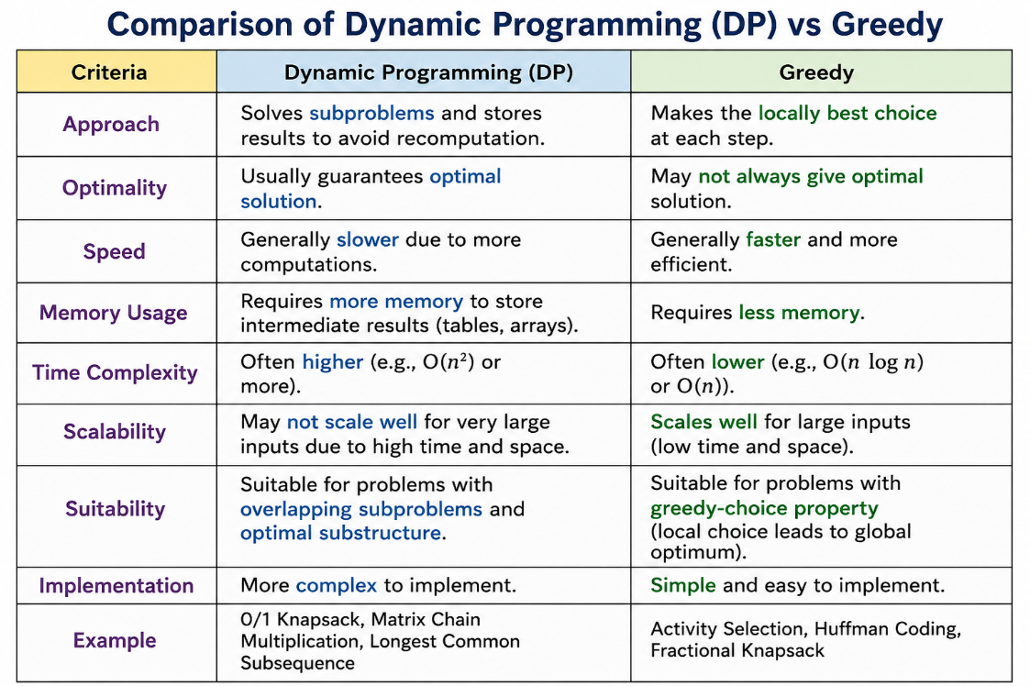
3. Advantages of DP
- Guarantees an optimal solution when the problem has optimal substructure.
- Avoids repeated calculations using memoization/tabulation.
- Suitable for complex optimization problems.
- Can handle problems where greedy choices fail.
4. Disadvantages of DP
- Requires high memory usage because intermediate results are stored.
- Usually more complex to implement.
- Can have higher time complexity.
- May not scale well when the number of states becomes very large.
5. Advantages of Greedy
- Simple and easy to implement.
- Requires less memory.
- Usually has better execution speed.
- Suitable for large datasets when the greedy-choice property holds.
6. Disadvantages of Greedy
- Does not always produce an optimal solution.
- A locally best choice may result in a poor overall solution.
- It is difficult to correct an earlier greedy decision.
- Applicable only when the problem has the greedy-choice property.
7. Example: Knapsack Problem
For the 0/1 Knapsack problem, DP can examine combinations of items and find the maximum possible value.
A simple greedy method based on value-to-weight ratio may be faster, but it cannot always guarantee the optimal solution for 0/1 Knapsack.
8. Computational Complexity
- DP: Commonly around O(nW) for 0/1 Knapsack, where n is the number of items and W is capacity.
- Greedy: Often O(n log n) when sorting is required.
Therefore, Greedy is generally faster, while DP provides stronger optimality guarantees for suitable problems.
9. How to Select the Algorithm
Use Greedy when:
- A locally optimal choice leads to a globally optimal solution.
- Fast execution is important.
- Memory is limited.
- The input size is large.
Use DP when:
- The problem has overlapping subproblems.
- An optimal solution is required.
- Greedy choices cannot guarantee optimality.
- Sufficient memory is available.
Conclusion
Greedy is preferred for speed, simplicity, and scalability, whereas Dynamic Programming is preferred when guaranteed optimality is more important than memory and execution time. The correct paradigm should be selected based on the problem structure, required accuracy, computational resources, and input size.

